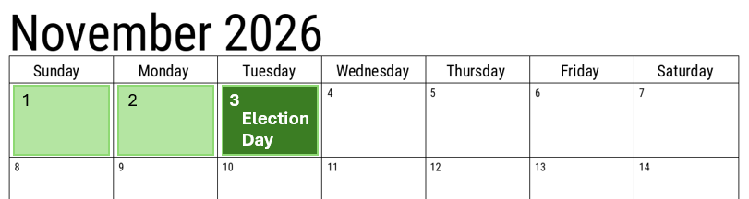
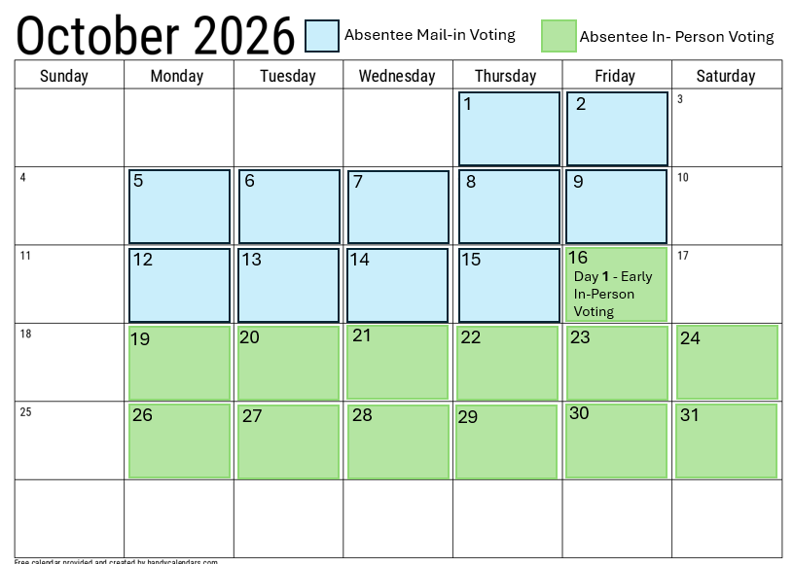
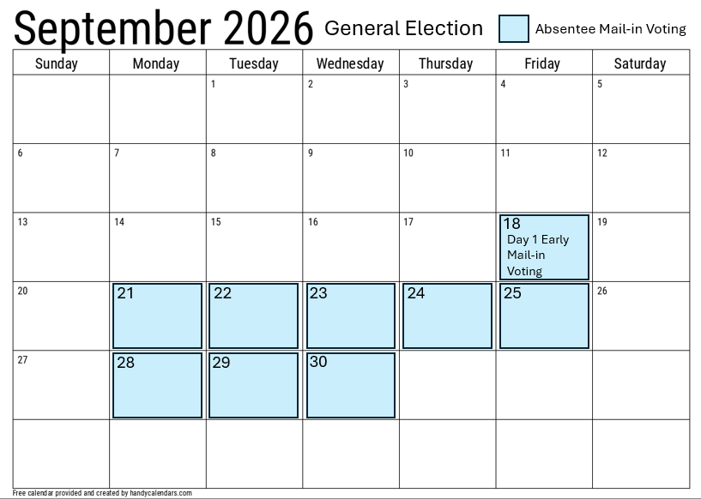

Primary 2026
Locations & Hours
MNVotes.org
Or
Vote Election Day
Tuesday, November 3, 2026

